**LA GRANDEE INTERNATIONAL COLLEGE**

**Simalchour – 8, Pokhara**

A Project Proposal

On

**Bus Ticketing System**

**Submitted To:**

LA GRANDEE INTERNATIONAL COLLEGE

Bachelor of Computer Application (BCA) Program

*In partial fulfillment of the requirements for the degree of Program Name under*

**POKHARA UNIVERSITY**

**Submitted By:**

|  |  |  |
| --- | --- | --- |
| **Name** | **Program, Semester** | **PU Registration No.** |
| Sarad Adhikari | BCA VI | 2022-1-53-0142 |
| Karun Sunuwar | BCA VI | 2022-1-53-0125 |
| Sabin Pandey | BCA VI | 2022-1-53-0139 |
| Anish Poudel | BCA VI | 2022-1-53-0118 |

**April, 2025**

# Abstract

The proposed project, the "**Bus Ticketing System**," is designed to modernize and streamline the ticket booking and management operations of a bus transportation service through a user-friendly web-based application developed using **PHP**, **HTML**, **CSS**, and **JavaScript**. The system serves both passengers and administrators, offering a wide array of features that enhance the booking experience and improve backend management processes.

For passengers, the system provides essential and convenient functionalities such as **online ticket booking, real-time seat availability checks, ticket cancellation, and the ability to modify existing bookings**. These features allow users to manage their travel plans with ease and flexibility, ensuring a smooth and hassle-free journey from start to finish.

For administrators, the application offers a powerful set of tools to manage and monitor the entire bus operation efficiently. This includes the ability to add and update bus schedules, manage routes and fare details, track bookings and cancellations, generate transaction reports, and oversee user accounts. Additionally, administrators can manage bus details, assign drivers, and ensure all data remains up-to-date and accurate.

By bringing together these functionalities into a cohesive and responsive web platform, the Bus Ticketing System not only increases the efficiency of the transportation service but also significantly improves user satisfaction by offering a fast, reliable, and easy-to-use booking experience. With its modern interface and comprehensive backend control, the system is set to transform traditional bus service management into a digital, more productive, and customer-focused model.

**Table of Contents**

Abstract ii

1. Introduction 1

2. Problem Statement 2

3. Objectives 3

4. Methodology 4

5. Project Gantt Chart 5

6. Deliverables 6

7. References 7

**List of Figures**

Figure 4‑1 Agile Model 4

Figure 5‑1 Gantt Chart 5

# Introduction

In an era where technology continues to transform the way we live and travel, the need for a faster, more reliable, and user-friendly transportation management system has become increasingly important. Traditional bus ticketing methods, such as over-the-counter bookings and manual record-keeping, are not only time-consuming but also prone to human error and inefficiency. These outdated systems often result in long queues, mismanagement of bookings, and a lack of real-time information for both passengers and operators. To overcome these challenges and modernize the public transportation experience, the Bus Ticketing System has been developed as a comprehensive web-based solution.

The Bus Ticketing System is an innovative application built using PHP, HTML, CSS, and JavaScript, designed to simplify and automate the entire process of booking and managing bus tickets. This system allows passengers to search for available buses, view schedules, check seat availability in real time, book tickets, cancel reservations, and modify existing bookings—all through an easy-to-use online platform. By eliminating the need for physical presence during the booking process, it enhances convenience, saves time, and ensures a smooth and hassle-free travel experience.

On the administrative side, the system offers robust tools for managing bus operations. Administrators can add and update bus schedules, manage routes and pricing, assign buses and drivers, view booking and cancellation reports, and handle user accounts efficiently. The system ensures data consistency, improves accuracy, and enables better decision-making through real-time access to operational data.

By integrating all these functionalities into a unified platform, the Bus Ticketing System not only improves customer satisfaction but also boosts the overall efficiency and profitability of bus service providers. It brings a modern, digital approach to public transportation management, offering a scalable and secure solution that can adapt to the growing needs of the industry.

# Problem Statement

* Bus transportation services often face significant operational inefficiencies that impact both customer satisfaction and internal management performance.
* Manual ticket booking systems, commonly used in bus stations, are prone to human error, overbooking, and mismanagement of schedules and seats, leading to delays and passenger frustration.
* Lack of real-time information about seat availability, bus schedules, and ticket status creates confusion for passengers and increases dependency on physical inquiries or customer service desks.
* Absence of a centralized digital platform makes it difficult for transport operators to manage route plans, monitor transactions, update fare structures, or generate timely performance reports.
* Passengers often struggle with last-minute ticket availability, lack of flexible booking options, and poor visibility into upcoming bus schedules, which reduces customer trust and loyalty.
* Physical ticket counters are subject to overcrowding, especially during peak seasons, causing long queues, slow service, and customer dissatisfaction.

# Objectives

The existing ticket booking and management system used by many bus transportation services is often manual, inefficient, and vulnerable to human error, resulting in operational delays, customer dissatisfaction, and financial losses. The proposed **Bus Ticketing System** web application aims to automate and streamline the entire ticketing process through an intuitive and accessible interface for both passengers and administrative staff.

**The problems before the proposal of this system were:**

* Enable seamless ticket booking and cancellation processes.
* Enhance route and schedule management.
* Implement robust transaction tracking and reporting.
* Ensure administrative control, role-based access, and system security.
* Ensure scalability and flexibility.

# Methodology

For the development of the “Bus Ticketing System” web application, we’ll be using the Agile methodology, a flexible and iterative approach to software development. Agile focuses on delivering small, functional pieces of the application through continuous planning, development, and testing. It promotes collaboration, adaptability to change, and frequent delivery of working software (Beck et al., Manifesto for Agile Software Development, 2001).

Agile methodology is particularly well-suited for projects like this that require regular updates, evolving features, and client feedback. Development is broken into short cycles known as iterations or sprints (usually 1–3 weeks), where each sprint delivers usable features such as booking modules, seat selection, admin controls, or transaction tracking.

In a nutshell, Agile requires the following key roles and practices:

1. A Product Owner defines and prioritizes the features in the Product Backlog.
2. The Development Team selects items from the backlog to build in each iteration.
3. At the end of each sprint, the team reviews and tests the new functionality.
4. Repeat

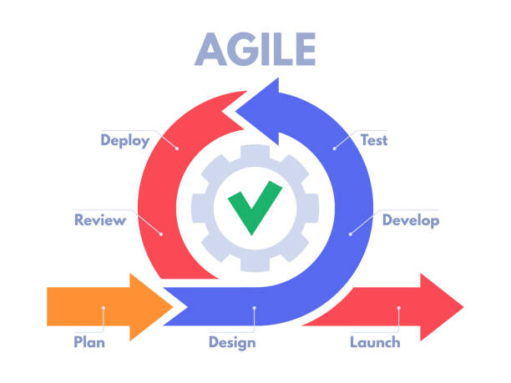

#### Figure ‑ Agile Model

# Project Gantt Chart

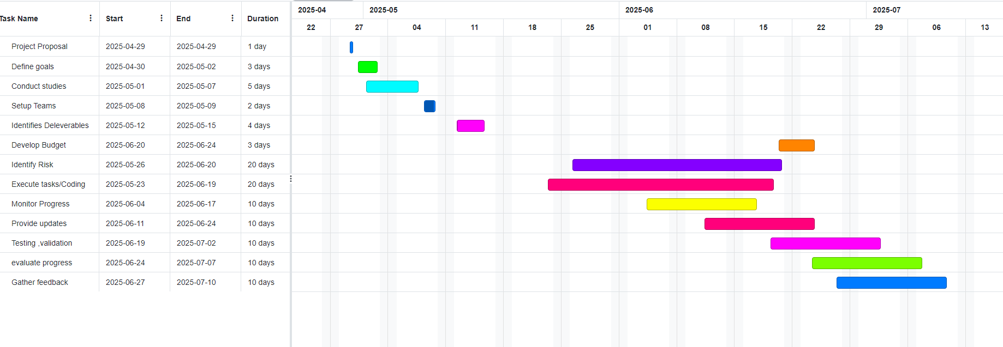

#### Figure ‑ Gantt Chart

# Deliverables

1. **Software Requirements Specification (SRS) Document:** A comprehensive document outlining both functional and non-functional requirements of the Bus Ticketing System. It includes modules like user registration, ticket booking, schedule management, payment integration, and administrative controls.
2. **Initial Prototype:** A basic working prototype demonstrating core functionalities such as user login/registration, viewing bus schedules, and initiating a ticket booking. This prototype helps gather early feedback from stakeholders and guide further development.
3. **Incremental Software Releases:** Regular releases of working software increments at the end of each sprint, showcasing the implemented features and functionalities.
4. **User Documentation:** Comprehensive documentation providing instructions on how to use the Bus Ticketing System, including user guides, manuals, and FAQs.
5. **Administrator Documentation:** Specific documentation tailored for Bus ticket administrators, detailing how to configure and manage the system, including employee management, service administration, and reporting.
6. **Test Cases and Test Reports:** Test cases for each feature of the Bus Ticketing System, along with test reports documenting the results of testing activities, including unit tests, integration tests, and user acceptance tests.
7. **Deployment Package:** A deployment package containing the necessary files and instructions for deploying the Bus Ticketing System in a production environment, including installation guides and system requirements.
8. **Training Materials:** Training materials, such as presentations and tutorials, to facilitate training sessions for Bus Ticket administrators and staff on how to use the Bus Ticketing System effectively.

By delivering these key project artifacts and milestones in an iterative and collaborative manner, the Agile-driven development of the **Bus Ticketing System** ensures a user-friendly, scalable, and robust solution that meets the evolving needs of passengers and bus operators alike.

# References

Henkin, G. (2023, 02 09). *Spa Management: Challenges and Opportunities*. Retrieved from Cayuga Hospitality Consultants: https://cayugahospitality.com/gary-henkin/spa-management-challenges-and-opportunities/

Schwaber, K. (2022). *What is Scrum?* Retrieved from Scrum: https://www.scrum.org/learning-series/what-is-scrum/

Schwaber, K., & Sutherland, J. (2020). *The 2020 Scrum Guide*. Retrieved from Scrum Guides: https://scrumguides.org/scrum-guide.html

Smith, M. K., & Wallace, M. (2020, 09 17). *An analysis of key issues in spa management: viewpoints from international industry professionals*. Retrieved from ResearchGate: https://www.researchgate.net/publication/345028672_An_analysis_of_key_issues_in_spa_management_viewpoints_from_international_industry_professionals